**Rags to Riches: The Journey of Starbucks!**

Luxury and Satisfaction are all there with the coffees and espressos of Starbucks!

Isn’t Starbucks your favorite brand too? But, Have you wondered how it all went and the success came to the doorsteps of Schultz?

Is every success story the same? Does every rag to riches story have similar endings and trends?

This time, we are going to look into the success story of Starbucks, and see their journey! Let us see what is the statistic with Starbucks. Is it going through a downfall too, or has it maintained its success and brand with the upcoming areas and competitions?

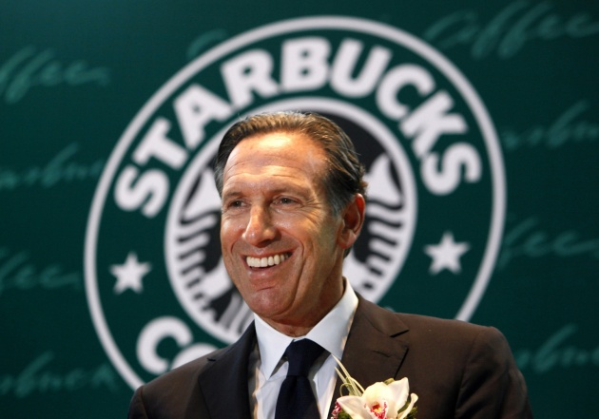

**Howard Schultz and his early hardships:**

Howard Schultz is the former CEO and executive chairman of Starbucks. He was born in Brooklyn, New York, in a Jewish family.

Schultz told ‘60 minutes’, how he was raised up in a poor family and his father has served various blue-collar jobs including factory worker, Truck Driver, and a cab driver, and also an ex-US troop. His father was never able to make more than $20,000 a year and had to feed all of the members in the family including his wife, Howard Schultz, and three siblings of Howard.

He discloses how his father always tried to fit in the system with various hardships, but couldn't pace up with the changes, and because of his low self-esteem, he was always a beaten-up man.

There was a time in 1961 when his father broke his ankle and his mother was pregnant and they couldn't work, so Howard and his siblings had to pick up the calls from the collectors and pretend as if they were home alone. At that time, they were with no income, no Health Insurance, no compensation, and they had nothing to rely upon for a living.

**Schultz’s higher education and jobs:**

Howard Schultz completed his graduation from Northern Michigan University with a scholarship in 1975, and here is how he started earning:

* He worked as a salesman for Xerox Corporation and later as a full sales representative there.
* In 1979, however, he shifted to the Swedish coffee maker as General Manager for United States corporations with a staff of 20 members.
* In 1981, Howard Schultz visited Seattle and was highly impressed with the Starbucks Coffee Company that had only four shops at that time.
* A year later, in 1982, Schultz joined Starbucks as the director of retail operations and marketing because of how he was impressed with the company's knowledge of coffee.
* In his trip to Milan, Italy, in 1983, Schultz was highly impressed with the serving style of the coffee bars for excellent Espressos and how they provided a space for people to meet in these cafes.
* He then left Starbucks and started his own company II Giornale Coffeehouses.

**Buying Starbucks and maintaining the success trend with various openings!**

After some years, in 1987, Schultz returned to Starbucks, but this time not to work as an employee but to buy the coffee shop with the help of a few investors and to take over as the CEO of Starbucks that had 17 store locations by that time. Howard Schultz purchased Starbucks at 3.8 million dollars and now he is the 232nd richest person in America according to Forbes, with a net worth of 3.1 billion dollars.

In 1988, Schultz committed to offering Health Insurance to the workers including all the domestic partners, and in 1991, he started offering “Bean Stocks” by making the employees as the partners in the company.

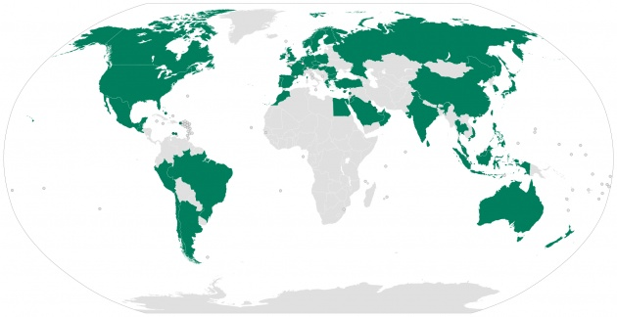

In 2000, Schultz resigned from the post of CEO and moved to the position of chief Global strategist to help the company expand internationally. In 2018, Starbucks had 28,000 stores in about 77 countries all across the world and has a capitalization value of 79.14 billion USD.

At present, the coffee sales made by Starbucks are highest among all the other coffee sellers and they repeatedly report to open 2 to 3 stores every few days. Starbucks has been able to attract about 60 million customers every week.

In June 2018 however stepped down as the chairman of Starbucks and now lives in Seattle, Washington with his wife and two children.

**Happy Ending!**

Howard Schultz turned the journey of Starbucks to make it the most preferred coffee-shop for the millions across the globe.

What we learned from Schultz is that he was determined, focused, and aimed to achieve the biggest branding with various strategies along with maintaining the quality and pacing up with the changes.